Greyhills Academy High School
Regular Governing Board Meeting
September 1, 2016 5:00 PM (DST)

Proposed Agenda

- Call Meeting to Order
- Roll Call
- Invocation
- Approval of Agenda
- Introduction of Guests
- Call to the Public
- Approval of Minutes
- August 4, 2016 (Regular Meeting)
- Reports
- Departments
- Principal
- New Business Action Items
- Approval of Payroll Expenditures Ending August 2016
- Approval of Accounts Payable Expenditures Ending August 2016
- Approval of Budget Report Ending August 2016
- Approval of Memorandum of Agreement between Greyhills Academy High School and Intel Corporation for 3 years beginning July 1, 2016
- Approval for school board travel to DBOSBA Fall Conference in Albuquerque, NM on September 16-17, 2016
- Approval for adjustment to general ledger for SY 2015-16 in the amount totaling: -$210,811.55
- Approval for one-step increase for all staff, excluding: new hires, recent adjustments, and employees off the salary schedule for SY 2016-17, retroactive to July 1, 2016
- Personnel
  - Approval to hire Ms. Freida A. Robbins as Homeliving Assistant for SY 2016-17
  - Approval to hire Ms. Madeline K. Sloan as Parent Educator for SY 2016-17
  - Approval to hire Jennifer N. Williams as Assistant Cross Country Coach for SY 2016-17
  - Approval to hire Fall Event Staff Workers for SY 2016-17
  - Approval to hire Class & Club Sponsors for SY 2016-17
  - Approval to hire Extended Day Program Staff for SY 2016-17
- Next Board Meeting: Thursday, October 6, 2016 at 5:00 PM
- Adjournment

(The governing board may go into executive session to discuss personnel and legal matters.)

Approval to Post Agenda:_____________________________ Date: __________________
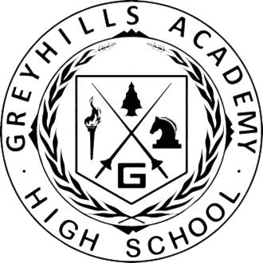
Dr. Loren Hudson, Principal

