Greyhills Academy High School
Regular Governing Board Meeting
May 5, 2016 5:00 PM (D.S.T.)

Proposed Agenda

- Call Meeting to Order
- Roll Call
- Invocation
- Approval of Agenda
- Introduction of Guests
- Call to the Public
- Approval of Minutes
- April 7, 2016 (Regular Meeting)
- Reports
- Departments
- Principal
- New Business Action Items
- Approval of Payroll Expenditures Ending April 2016
- Approval of Accounts Payable Expenditures Ending April 2016
- Approval of Monthly Budget Report Ending April 2016
- Approval of final reading for GAHS Housing Policy and Procedure Manual
- Approval of final reading for Quarters Lease Agreement/2015-2016 Rental Agreement
- Approval of first reading for Facilities Use Procedure and Rules
- Approval of first reading for School Facilities Application and Agreement
- Approval of School Calendar for SY 2016-17
- Report on Mahoney Group and Native American Schools Health Welfare Trust Plan Rate Change for GAHS
- Personnel
  - Approval of resignation for Vincent B. Nells effective April 22, 2016
  - Approval of resignation for Sarah Nez effective May 20, 2016
  - Approval of retirement for Kenneth Nez effective May 20, 2016
  - Approval of Summer Food Service Program from May 31 to June 24, 2016
  - Approval of Short-term Contract for Guidance Counselors (Odessa Reeves and Eugenia Sloan)
  - Approval of Short-term Contract for Principal’s Secretary from June 1-30, 2016 (Nicolette George)
  - Approval to hire Summer School Personnel from May 31 to June 24, 2016
  - Approval of Contract Renewals & Non-Renewals for SY 2016-17
K. Election of Board Officers
- Next Board Meeting: Thursday, June 2, 2016 at 5:00 PM (DST)
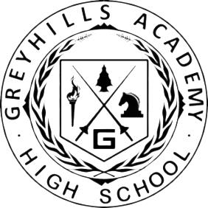
- Adjournment

(The governing board may go into executive session to discuss personnel and legal matters.)

Approval to Post Agenda:_____________________________ Date: __________________
Dr. Loren Hudson, Principal

