Greyhills Academy High School
Regular Governing Board Meeting
April 7, 2016 5:00 PM (D.S.T)

Proposed Agenda

- Call Meeting to Order
- Roll Call
- Invocation
- Approval of Agenda
- Introduction of Guests
- Call to the Public
- Approval of Minutes
- March 3, 2016 (Regular Meeting)
- Reports
- Departments
- Principal
- New Business Action Items
- Approval of Payroll Expenditures Ending March 2016
- Approval of Accounts Payable Expenditures Ending March 2016
- Approval of Budget Report for Month Ending March 2016
- Approval of 2016 Budget Modifications for Transportation, Facilities, ESS Part B, and Administrative Cost
- Approval of third reading for GAHS Housing Policy and Procedure Manual
- Approval of third reading for Quarters Lease Agreement/2015-2016 Rental Agreement
- Approval of final reading for GAHS School Board Policies
- Approval of final reading for GAHS Governing Board By-Laws FY 2015-16
- Approval of 21st CCLC Summer Enrichment Program from May to June 2016
- Next Board Meeting: Thursday, May 5, 2016 at 5:00 PM (D.S.T.)
- Adjournment

(The governing board may go into executive session to discuss personnel and legal matters.)

Approval to Post Agenda:_____________________________ Date: __________________
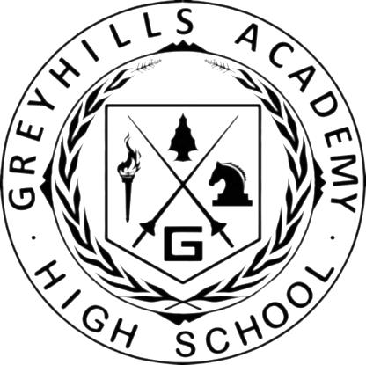
Dr. Loren Hudson, Principal

