Greyhills Academy High School
Special Governing Board Meeting
June 8, 2017 6:00 PM (DST)

Proposed Agenda

- Call Meeting to Order
- Roll Call
- Invocation
- Approval of Agenda
- New Business Action Items
- Performance Evaluation for Dr. Loren Hudson for SY 2016-17
- Approval of employment contract for Dr. Loren Hudson for SY 2017-19
- Adjournment

(The governing board may go into executive session to discuss personnel and legal matters.)

Approval to Post Agenda:_____________________________ Date: __________________
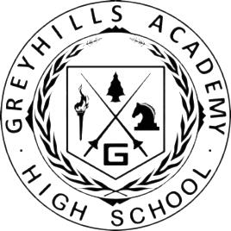
Richard Grey, Assistant Principal

