Greyhills Academy High School
Regular Governing Board Meeting
June 1, 2017 6:00 PM (DST)

Proposed Agenda

- Call Meeting to Order
- Roll Call
- Invocation
- Approval of Agenda
- Introduction of Guests
- Call to the Public
- Approval of Minutes
- May 4, 2017 (Regular Meeting)
- Reports
- Departments
- Principal
- New Business Action Items
- Approval of Payroll Expenditures Ending May 2017
- Approval of Accounts Payable Expenditures Ending May 2017
- Approval of Financial Status Ending May 2017
- Approval of Proposed Budget for SY 2017-18
- Approval of BIE Division of Performance and Accountability Annual Report for SY 2016-17
- Personnel
  - Approval of Short-Term Contract for Robert Talashoma as Assistive Technology Technician from July 3-14, 2017
  - Approval of Short-Term Contract for Rolanda Farrell as Residential Facility Worker from June 12-30, 2017
  - Approval Short-Term Contract for Sarah Hurley as Residential Facility Worker from June 12-30, 2017
  - Approval of Short-Term Contract for Zelda Tahy as Residential Facility Worker from June 12-30, 2017
- Adjournment

(The governing board may go into executive session to discuss personnel and legal matters.)

Approval to Post Agenda:_____________________________ Date: __________________
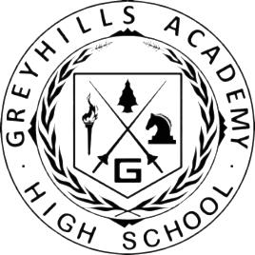
Dr. Loren Hudson, Principal

