Greyhills Academy High School
Regular Governing Board Meeting
May 4, 2017 6:00 PM (DST)

Proposed Agenda

- Call Meeting to Order
- Roll Call
- Invocation
- Approval of Agenda
- Introduction of Guests
- Call to the Public
- Approval of Minutes
- April 6, 2017 (Regular Meeting)
- Reports
- Departments
- Principal
- New Business Action Items
- Approval of Payroll Expenditures Ending April 2017
- Approval of Accounts Payable Expenditures Ending April 2017
- Approval of Financial Status Ending April 2017
- Approval of Resolution #2017-004: Approving Withdrawal of Interest Funds in the amount of $200,000.00 from the Morgan Stanley Investment Account
- Approval of Intergovernmental Agreement between Coconino Community College District and Greyhills Academy High School for SY 2017-18
- Approval of Focal School Agreement between Office of Dine’ Science, Math, and Technology and Greyhills Academy High School for SY 2017-18
- Approval of ESS Part B Application for SY 2017-18
- Approval of Out-of-State student travel for Girls Basketball Club to Durango, CO to attend Fort Lewis Women’s Basketball Team Camp on June 2-4, 2017 at cost of $2,425.00
- Personnel
  - Approval of Contracts for School Year 2017-18
  - Approval of Contracts for Summer School 2017
  - Approval of the Summer Food Service Program from June 5-30, 2017
  - Approval of Short-Term Contracts for ESS Extended School Year Personnel
  - Approval of Short-Term Contract for Behavioral Health Specialist
- Next Board Meeting: Thursday, June 1, 2017 at 6:00 PM (DST)
- Adjournment
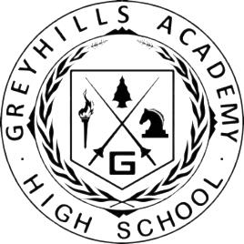

(The governing board may go into executive session to discuss personnel and legal matters.)

Approval to Post Agenda:_____________________________ Date: __________________
Dr. Loren Hudson, Principal

