Greyhills Academy High School
Regular Governing Board Meeting
February 2, 2017 6:00 PM

Proposed Agenda

- Call Meeting to Order
- Roll Call
- Invocation
- Approval of Agenda
- Introduction of Guests
- Call to the Public
- Approval of Minutes
- January 5, 2017 (Regular Meeting)
- Reports
- Departments
- Principal
- New Business Action Items
- Approval of Payroll Expenditures Ending January 2017
- Approval of Accounts Payable Expenditures Ending January 2017
- Approval of Financial Status Ending January 2017
- Approval of School Calendar for SY 2017-18
- Approval of GAHS Resolution #2017-001: Requesting the Agency Councils of the Navajo Nation Council to support continuing reauthorization of Greyhills Academy High School under provisions of Public Law 100-297
- Approval of GAHS Resolution #2017-002: Requesting the ( ) Chapter of the Navajo Nation Council to support continuing reauthorization of Greyhills Academy High School under provisions of Public Law 100-297
- Personnel
  - Approval to hire Annette Hemstreet as Head Track/Field Coach
  - Approval to hire Vaughn Salabye as Assistant Track/Field Coach
  - Approval to hire Bryon Bronston as Head Baseball Coach
  - Approval to hire Jonathan Hemstreet as Assistant Baseball Coach
  - Approval to hire Fidel Begishie as Head Softball Coach
  - Approval to hire Nicolette George as Assistant Softball Coach
  - Approval to hire Spring Sports Event Staff for SY 2016-17
- Next Board Meeting: Thursday, March 2, 2017 at 6:00 PM
- Adjournment

(The governing board may go into executive session to discuss personnel and legal matters.)

Approval to Post Agenda:_____________________________ Date: __________________
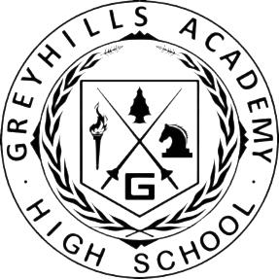
Dr. Loren Hudson, Principal

