Greyhills Academy High School
Regular Governing Board Meeting
January 5, 2017 5:00 PM

Proposed Agenda

- Call Meeting to Order
- Roll Call
- Invocation
- Approval of Agenda
- Introduction of Guests
- Call to the Public
- Approval of Minutes
- December 1, 2016 (Regular Meeting)
- Reports
- Departments
- Principal
- New Business Action Items
- Approval of Payroll Expenditures Ending December 2016
- Approval of Accounts Payable Expenditures Ending December 2016
- Approval of Financial Status Ending December 2016
- Personnel
  - Approval of Resignation for Eric Tooke (Teacher) effective January 13, 2017
  - Approval to hire Jason Begay as Teacher for SY 2016-17
  - Approval to hire Dr. Fonda Walters as Teacher for SY 2016-17
  - Approval to hire Jerell Nells as Music Teacher for the Extended Day Program for SY 2016-17
  - Approval to hire Regina Hale as Senior Class Sponsor for SY 2016-17
- Next Board Meeting: Thursday, February 2, 2017 at 5:00 PM
- Adjournment

(The governing board may go into executive session to discuss personnel and legal matters.)

Approval to Post Agenda:_____________________________ Date: __________________
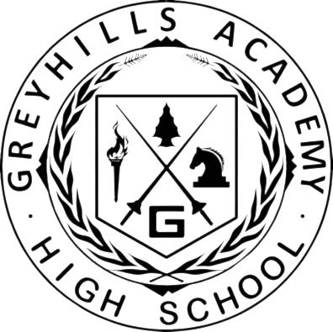
Dr. Loren Hudson, Principal

